PHASE 3 – PROJECT DESIGN

1. Introduction

The Project Design phase defines the overall structure and technical design of the LegalEase: AI-Powered Legal Document Generator. The design converts the requirements identified in the Requirement Analysis phase into a structured system that explains how users, frontend components, backend services, AI integration, document formatting modules, and output files interact with each other.
LegalEase is designed using Streamlit for the frontend, Fast API for the backend, Google Gemini for AI-powered document generation, and separate formatting components for generating TXT, DOCX, and PDF documents.
2. System Design Objectives
The main objectives of the LegalEase system design are:
* To define the overall architecture of the application.
* To establish the communication between the frontend and backend.
* To define the interaction between FastAPI and Gemini AI.
* To design the document generation workflow.
* To define the input and output flow of the system.
* To design the document preview and editing process.
* To define the document export process.
* To provide a modular structure for the application
3. Overall System Architecture
The LegalEase system follows a layered architecture consisting of the following major components:
3.1 Frontend Layer
The frontend is developed using Streamlit. It provides the user interface for:
* Entering document type
* Entering parties
* Entering terms and conditions
* Entering effective dates
* Generating the document
* Previewing generated content
* Editing the document
* Downloading the final document
3.2 Backend Layer
The backend is developed using FastAPI.
The backend is responsible for:
* Receiving requests from the Streamlit frontend.
* Validating the input.
* Processing document generation requests.
* Communicating with the Gemini AI component.
* Returning generated content to the frontend.
The main API endpoint used for document generation is:
POST `/generate`
3.3 AI Integration Layer
The AI integration is handled through the Gemini model.
The `GeminiDocumentGenerator` receives structured information from the backend, forms an appropriate prompt, sends it to Gemini, and returns the generated legal document content.
3.4 Document Formatting Layer
The generated content is processed by formatting functions to create different output formats.
The major formatting functions are:
* `format_docx(text, doc_type)`
* `format_pdf(text, doc_type)`
* `format_html_preview(text)`
The system also provides TXT output for plain-text documents.
3.5 Output Layer
The final document can be:
* Previewed in the application.
* Edited by the user.
* Downloaded as TXT.
* Downloaded as DOCX.
* Downloaded as PDF.
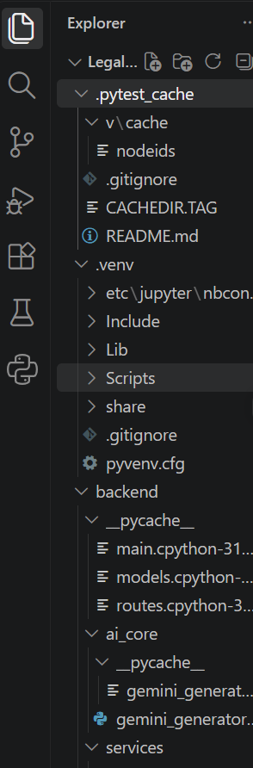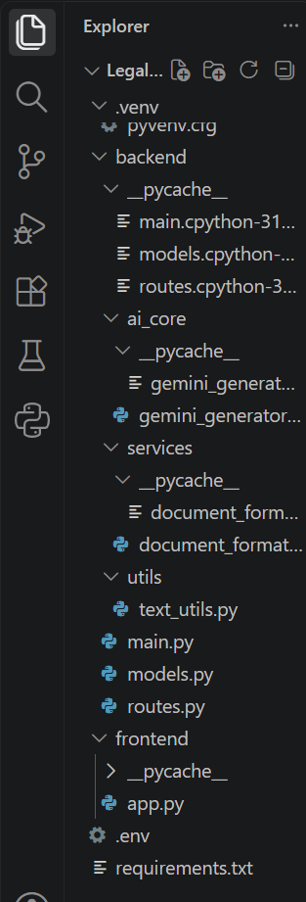
Figure 3.1: System Architecture of LegalEase
4. Frontend Design
The LegalEase frontend is developed using Streamlit.
The interface is designed to provide the required input fields and document generation controls in a simple layout.
Input Components
The frontend accepts:
* Document Type
* Parties
* Terms & Conditions
* Effective Date
Action Components
The interface provides options for:
* Generate Document
* Edit Document
* Download as TXT
* Download as DOCX
* Download as PDF
The generated document is displayed in a styled preview area.
5. Backend Design
The backend uses FastAPI to provide the API services required by the frontend.
The backend structure includes:
* `main.py`
* `routes.py`
main.py
The `main.py` file is responsible for:
* Initializing the FastAPI application.
* Defining the root `/` endpoint.
* Including the application routes.
routes.py
The `routes.py` file is responsible for:
* Defining the `DocumentRequest` Pydantic model.
* Validating incoming document information.
* Creating the `/generate` POST endpoint.
* Calling `GeminiDocumentGenerator.generate_document()`.
6. AI Integration Design
The AI component is integrated through the Gemini model.
The document generation process follows these steps:
1. The user enters the required legal information.
2. Streamlit sends the information to the FastAPI backend.
3. FastAPI validates the request.
4. The request is passed to `GeminiDocumentGenerator`.
5. A structured prompt is created using the user inputs.
6. The prompt is sent to Gemini using the generation function.
7. Gemini returns the generated legal content.
8. FastAPI returns the generated content to Streamlit.
9. Streamlit displays the generated document for preview and editing.
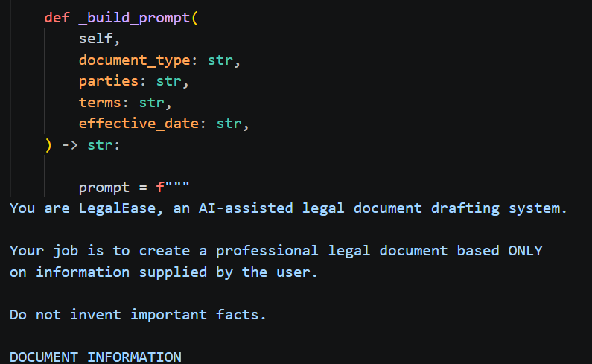
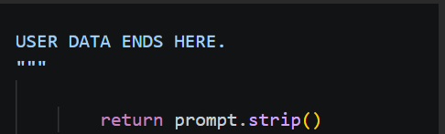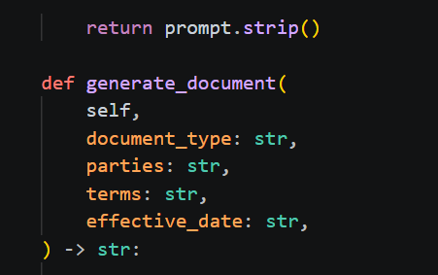
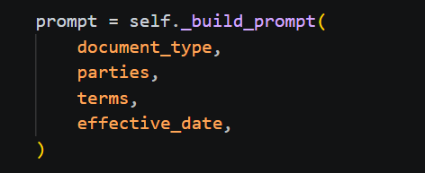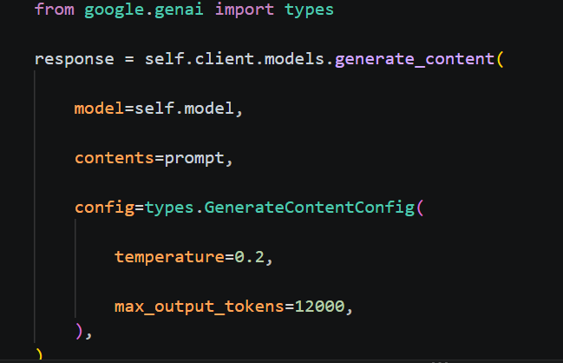
Figure 3.2: AI-Powered Document Generation Flow
7. Data Flow Diagram
The Data Flow Diagram represents how information moves through the LegalEase system.
Level 0 – Context Level
The main external entity is the User.
The user provides legal document information to LegalEase. The system processes the information using the AI generation component and returns the generated legal document.
User → LegalEase → Generated Legal Document
Level 1 – Detailed Data Flow
The detailed flow can be represented as:
User
↓
Streamlit Frontend
↓
FastAPI `/generate` API
↓
DocumentRequest Validation
↓
GeminiDocumentGenerator
↓
Gemini AI
↓
Generated Legal Content
↓
Preview / Edit
↓
TXT / DOCX / PDF Output
8. Use Case Design
The main actor in the LegalEase system is the User.
The user interacts with the following major functions:
* Enter Document Details
* Generate Legal Document
* Preview Document
* Edit Document
* Download TXT
* Download DOCX
* Download PDF
User Use Cases
User → Enter Document Details
User → Generate Document
User → Preview Document
User → Edit Document
User → Download Document
9. Document Generation Workflow
The document generation workflow is designed as follows:
Step 1 – Input
The user enters:
* Document type
* Parties involved
* Terms and conditions
* Effective date
Step 2 – API Request
The Streamlit frontend sends the information to the FastAPI `/generate` endpoint.
Step 3 – Input Validation
The `DocumentRequest` model validates the incoming information.
Step 4 – AI Processing
The validated information is passed to the `GeminiDocumentGenerator`.
Step 5 – Content Generation
Gemini generates structured legal document content according to the provided information.
Step 6 – Preview
The generated content is returned to Streamlit and displayed as a styled HTML preview.
Step 7 – Editing
The user can modify the generated document through the editable text area.
Step 8 – Export
The final document can be downloaded in:
* TXT
* DOCX
* PDF

10. Document Formatting Design
LegalEase uses separate formatting functions for different output formats.
10.1 DOCX Design
The `format_docx()` function uses `python-docx` to create formatted Word documents.
The DOCX design can include:
* Logo
* Document title
* Paragraph formatting
* Terms table
* Footer
10.2 PDF Design
The `format_pdf()` function uses FPDF to create formatted PDF documents.
The PDF design can include:
* Logo
* Section headings
* Bullet-style terms
* Header/footer
10.3 HTML Preview Design
The `format_html_preview()` function converts the generated content into styled HTML blocks for display inside the Streamlit interface.
11. Application Module Design
The LegalEase application is divided into logical modules to maintain a structured architecture.
12. Security Design
The Gemini API key is stored using an environment configuration file rather than directly exposing the key in the application code. The project uses a `.env` file for storing sensitive configuration information such as the Gemini API key.
Module | Main Reponsibility
Streamlit Frontend | User interaction and document
FastAPI Backend | API request processing
‘main.py’ | FastAPI application initialization
‘routues.py’ | API routes and request handling
Gemini Generator | AI-based document generation
DOCX Formatter | Word document generation
PDF Formatter | PDF document generation
HTML Preview | Styled document preview
TXT Export | Plain-text document generation

This design helps prevent sensitive credentials from being directly included in the source code.
13. User Interface Flow
The overall user interface flow is:
Open LegalEase
↓
Enter Document Type
↓
Enter Parties
↓
Enter Terms & Conditions
↓
Enter Effective Date
↓
Generate Document
↓
View Generated Document
↓
Edit Document if Required
↓
Download TXT / DOCX / PDF
This flow provides a simple path from user input to the final legal document.
14. Design Summary
The LegalEase design provides a clear separation between the frontend, backend, AI processing, document formatting, and output components.
The Streamlit frontend manages user interaction, while FastAPI handles API requests. The Gemini AI component generates the legal content, and the formatting modules convert the generated content into the required document formats.
This modular architecture provides the foundation for implementing the LegalEase application in the development phase.
15. Conclusion
The Project Design phase defines the technical structure and working flow of the LegalEase system. The architecture establishes the relationship between Streamlit, FastAPI, Gemini AI, document formatting components, and the final document outputs.
The system design also defines the data flow, user interactions, document generation workflow, application modules, and security approach. These design specifications provide the required foundation for implementing the LegalEase application during the Project Development phase.

